University of Virginia Center for Politics
Talking Turkey: Social Justice

Referendum Question: What are the most important social justice concerns facing our nation today, and how can we help promote reform—if needed—in these areas?

General Facts:
Social justice is a broad term for political advocacy movements to increase equal opportunities for certain economic, political, and social rights. There are many social justice issues facing our nation today, and several have become highly politicized. Issues of Climate Justice, Gun Violence, and Abortion Rights are all social justice issues with which the two dominating political parties—Democrats and Republicans—have clearly defined viewpoints on. Other major social justice movements may include, but are not limited to: Women’s Rights, Black Lives Matter, Reproductive Rights, Poverty and Income Inequality, Criminal Justice, Immigrant Rights, Food Insecurity, and Voting Rights.

Questions people might ask about the topic:
- How do social justice movements get started? Social justice movements have gained traction in many ways. Lots of platforms take advantage of local protests, petitions, and conversations with elected officials in support of their respective issues. Some of our nation’s largest social justice movements have been started by marginalized groups, such as the Civil Rights Movement of the 1950s-60s for African American political and social rights.
Learn more here!

- What are grassroots movements? A grassroots movement is an organized collective action for political change in a specified area. Grassroots movements are a bottom-up way of implementing change, meaning advocacy begins at a hyper-local level. In doing this, grassroots movements look to expand to other local regions, continuously expanding involvement until it reaches national or international levels.
Learn more here!

- How did the Black Lives Matter movement begin? The Black Lives Matter movement began as the project “#BlackLivesMatter”, which was a political response to the acquittal of George Zimmerman, the man who shot and killed 17-year-old Trayvon Martin in February of 2012. Today, the project has reached almost all corners of the globe and has more than 40 member-led chapters.
Learn more here!

- What is Antifa? Antifa, a shortened version of the phrase “anti-fascist”, caused lots of controversy throughout much of the racial justice movements of 2020. Antifa is not a defined group with leaders and membership, but rather a loose affiliation of left-wing activists across the country. According to the New York Times, “Antifa members campaign against actions they view as authoritarian, homophobic, racist, or xenophobic”. Supporters of the movement are generally looking to stop far-right movements from promoting fascist and racist platforms. Much of the controversy surrounding this loosely affiliated group is their justification of violence. Learn more here!

- What does “Environmental Justice” mean? Many minority and low-income groups are disproportionately affected by the negative consequences of climate change. Environmental Justice is the application of this understanding to the development and implementation of environmental laws and regulations to ensure that all people are treated fairly. Learn more here!

- What does “systemic racism” mean? Systemic racism refers to the racial discrimination that is embedded in our institutions, laws, and policies. Different from individual racism, there is no intent behind systemic racism; however, many laws that don’t explicitly mention race still contribute to systemic racism. One example of this can be seen through housing practices. While there are no explicit federal laws that discriminate against Black Americans when it comes to housing, the history of redlining and segregation practices has created today’s reality that Black Americans are more than twice as likely than White Americans to be denied a mortgage or loan for their home (HumanRightsCareers.com). Learn more here!

- What does state legislation on Abortion currently look like? As of November 2023, 21 states have abortion bans or restrictions that violate the now-overturned Supreme Court ruling Roe v. Wade. Below is a map of the states with the following types of bans: full ban; 6-week ban; 12-week ban; or 15-18-week ban: Learn more here!
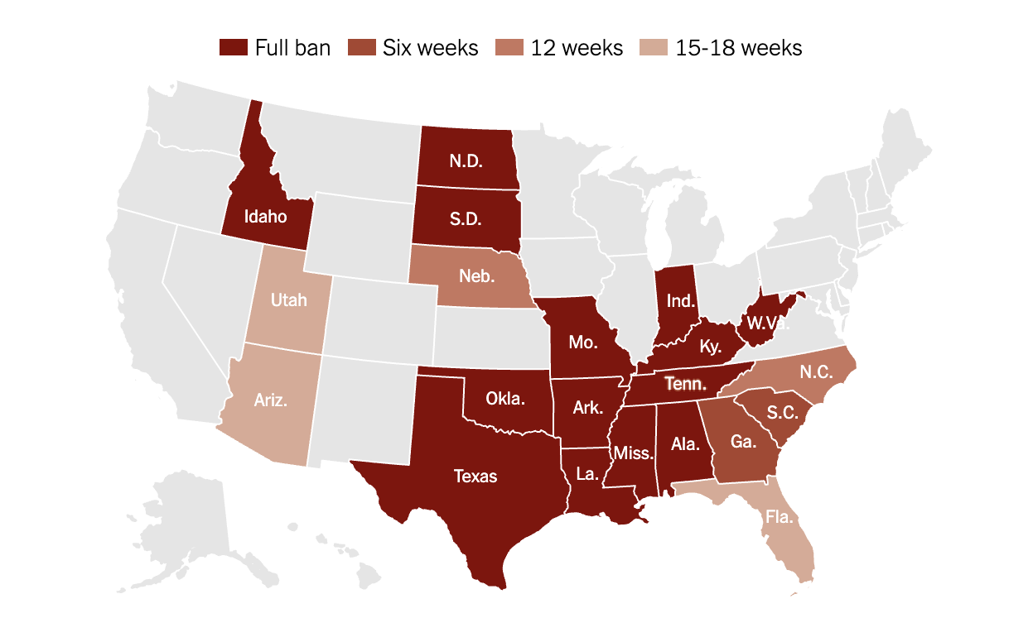

- What is the difference between equality and equity? Equality is the concept of providing all groups of people with the exact same resources and opportunities. Equity considers the idea that some groups have differing circumstances that require more resource allocation and opportunities to reach a truly equal situation. Learn more here!

- What role does the federal government play in social justice issues? Many politicians running for national offices will champion the promotion of certain social justice issues as a part of their campaign. For example, President Biden made promises to advance racial justice if he were elected as president, and on his first day in office he signed an executive order to advance racial equity. Learn more here!

- How do social justice movements measure success? Success is most often measured for social justice movements through the efficacy of lobbying efforts, how much related legislation their efforts have gotten passed, and any mobilization tactics, like protests or strikes. Learn more here!

Resources:
Dialogues on Diversity: https://www.dialoguesondiversity.com/social-justice-resources Dialogues on Diversity provides individuals with a greater understanding of how prejudice operates in the world around us. The website provides links to national programs that support dialogue on a wide range of topics.

Learning for Justice: https://www.learningforjustice.org/
Learning for Justice provides educational resources and social justice activities regarding race & ethnicity, religion, ability, class, immigration, bullying & bias, and rights & activism.

The Constitution and Beyond: Supreme Court cases regarding social justice issues
LGBTQ+ Rights:
Obergefell v. Hodges (2015): The Supreme Court ruled in this case that the 14th Amendment’s Equal Protection and Due Process Clauses protect an individual’s fundamental right to marriage, which includes the marriage of same-sex couples. Learn more here!
Abortion Rights:
Roe v. Wade (1972): A woman from Dallas challenged a Texas law that made all abortion illegal except in the case of the mother’s life. She alleged that the Texas abortion law violated her right to personal privacy, protected by the 1st, 4th, 5th, 9th, and 14th Amendments. The Supreme Court agreed with Roe (a fictional name given to keep the plaintiff anonymous) that the Texas law was unconstitutional. The Court ruled that certain variables must be taken into consideration regarding abortion legislation, such as the date of fetal viability and the health of the mother. Learn more here!

Dobbs v. Jackson Women’s Health Organization (2022): A Mississippi law that was passed in 2018 prohibited essentially all abortions after 15 weeks’ gestational age. Jackson Women’s Health Organization was the only licensed abortion clinic in the entire state, and one of its doctors filed a lawsuit challenging the law. Controversially, the Supreme Court ruled that Mississippi’s law was not unconstitutional, as the Constitution does not present the right to an abortion in its text. The Court also used a historical test to determine the legitimacy of the right, arguing in the majority opinion that the right to an abortion is not deeply rooted in the country’s history and therefore should not be a protected liberty.
Learn more here!
Race-related cases:
Students for Fair Admissions v. President and Fellows of Harvard College (2023): The Students for Fair Admissions (SFFA) sued Harvard College, arguing that their admissions process, with the use of affirmative action, violated Title VI of the Civil Rights Act of 1964. In a highly controversial decision, the Supreme Court ruled in favor of SSFA, stating that the Harvard Admissions process failed the strict scrutiny test, as universities do not provide a compelling interest to use race in their admissions process. Learn more here!
Loving v. Virginia (1967): The state of Virginia charged an interracial couple for violating the state’s “anti-miscegenation” law, which banned interracial marriages. The couple, the Lovings, argued that the Virginia law violated the Equal Protection Clause of the 14th Amendment. In a unanimous decision, the Supreme Court agreed, saying that distinctions drawn according to race are unconstitutional. Learn more here!
Climate Justice:
West Virginia v. Environmental Protection Agency (2022): Under the Trump Administration, previous legislation regarding guidelines on how much carbon dioxide power plants could emit was repealed and replaced by the Affordable Clean Energy Rule, which essentially eliminated all previous regulations. The question in front of the Supreme Court was whether the Environmental Protection Agency (EPA), the federal agency in charge of these climate-related acts, had the power to regulate greenhouse gas emissions at all. In a rather controversial conclusion, the Supreme Court ruled that the EPA did not have the direct authority from Congress to be making these decisions. Learn more here!

Political Parties and the major social justice movements they support:
Republican Party:
The Republican Party has a less defined platform regarding social justice issues. Because the Republican Party historically tends to advocate for less government involvement, their perspective on social justice differs significantly from that of other parties. Republicans mostly firmly promote the right to economic freedom. Heritage.org argues that economic justice issues should be dealt with through a “natural law account” that would allow policies to “empower more people to engage for themselves in the market and flourish”. Learn more about economic conservatism here!

Democratic Party Position:
Democrats today are fighting for the protection of voting rights, LGBTQ+ rights, reproductive rights, criminal justice reform, and gun violence reduction efforts. Another large effort for the Democratic Party most recently has been advancing racial justice. The Democratic Party is more likely to recognize past legislation and institutional structure continue to have a large impact on the current inequities minority groups face in America. Additionally, the Democratic Party is more likely to present legislation to alleviate the income gap between races and advocate for improving economic mobility for marginalized groups. Learn more about the Democratic Party’s views on social justice here!

Green Party: https://www.gp.org/social_justice

Libertarian Party: https://www.lp.org/platform/

Socialist Party: https://www.socialistpartyusa.net/principles-points-of-agreement

Conservative Sites:
- Heritage Foundation: “Conservatives Do Believe in Social Justice. Here’s What Our Vision Looks Like”
- National Review: “The Problem with ‘Social Justice’”
- RepublicanViews.org: “Republican Views on Civil Rights”

Liberal Sites:
- Democrats.org: Civil Rights
- Huffington Post: Social Justice
- Move On: a champion for progressive values

Citizen groups active in certain social justice movements:

Moms Demand Action: www.momsdemand.action
Students Demand Action: https://studentsdemandaction.org/
Climate Justice Alliance: https://climatejusticealliance.org/about/
Black Lives Matter: https://blacklivesmatter.com/
MSI United States: https://www.msiunitedstates.org/
National Fair Housing Alliance: https://nationalfairhousing.org/
The Trevor Project: https://www.thetrevorproject.org/

Talking Points with your Child—Get the discussion started!

- What social justice issues do you feel are most important today?
- Can you think of any current political events that have involved any social justice issues?
- Have you had conversations about any of these issues with friends or classmates?
- How can we be better allies to those issues that are important to us?
- What parts of the Constitution may apply to social justice movements? Learn about relevant parts of the Constitution here! And Here!

Links for Additional Info:
- “Race, Racism, and Racial Justice Resources”. This link takes you to a network of articles from the New York Times relating to race and its relevancy today.
- “Freedom of speech and LGBT rights: Americans’ views of issues in Supreme Court case”. This article presents survey responses from Americans on LGBT issues, political party views, and views of the religious on abortion access.
- “American Public Opinion and Gun Violence”. This article discusses American opinions on gun violence and the partisan divide on respective legislative efforts.
- “The U.S. Inequality Debate”. This link takes you to the Council on Foreign Relations’ website, where they discuss global income inequality, the significance of inequality, economic mobility, and the role of other income factors.

